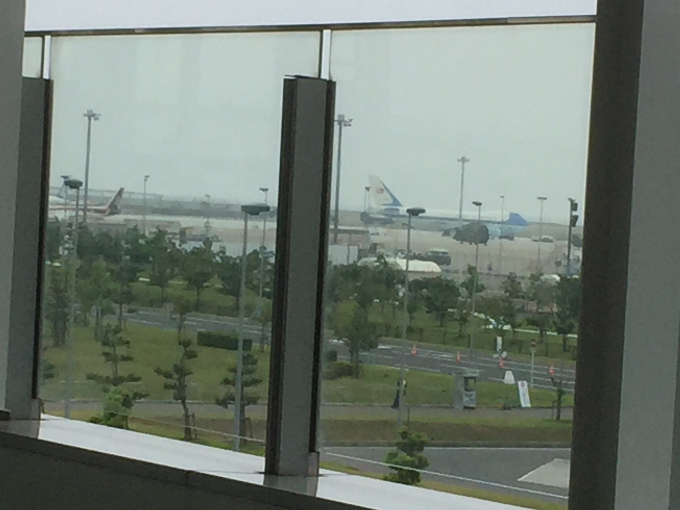
写真はセントレア駐車場ＢよりAirForceOneを（2016/05/26 10：30）撮影したもの。

下記はオバマ大統領に朝日新聞記者がインタビューしたもの
President Barack Obama said the U.S. commitment to Japan’s security remains absolute, America will stand with its partners in maritime disputes, and efforts will be made to prevent crimes by U.S. servicemen in Okinawa Prefecture.
Obama, who is in Japan for the Ise-Shima Group of Seven summit in Mie Prefecture, submitted written responses on May 26 to an exclusive interview with The Asahi Shimbun.
Although he did not respond to questions about the global economy, counterterrorism, the refugee crisis and other issues, the president said he intends to send a message of peace through his visit to Hiroshima while continuing to pursue his goal of a world free of nuclear weapons.
The following are the questions and answers:
* * *
HIROSHIMA VISIT
Question: The White House announced that you will visit Hiroshima during your upcoming visit to Japan for the G7 Summit. Could you tell us why you decided to go to Hiroshima? If you make a speech in Hiroshima, what will be your message? There is some debate, both in the U.S. and Japan, over whether the US should apologize for dropping the bomb—please share your thoughts on this controversial issue. You advocated for a nuclear-free world in your 2009 Prague speech, but negotiations with Russia have stalled, North Korea now has nuclear weapons, and nuclear proliferation continues to be a serious threat. What is needed to pave the way for your vision of a “world without nuclear weapons?”
Answer: I look forward to visiting the Hiroshima Peace Memorial Park, and I appreciate the chance to do so with Prime Minister Abe. I’m coming, first and foremost, to remember and honor the tens of millions of lives lost during the Second World War. Hiroshima reminds us that war, no matter the cause or countries involved, results in tremendous suffering and loss, especially for innocent civilians. I will not revisit the decision to use atomic weapons in Hiroshima and Nagasaki, but I will point out that Prime Minister Abe and I coming to Hiroshima together shows the world the possibility of reconciliation—that even former adversaries can become the strongest of allies.
I won’t give a long speech, but I will also reflect on the vision I outlined in Prague—pursuing the peace and security of a world without nuclear weapons. I’ve always said that this vision might not be achieved in my lifetime, but we’ve made important progress. U.S. and Russian nuclear arsenals are on track to be at their lowest levels in six decades. I’ve reduced the number and role of nuclear weapons in our national security strategy. In an historic deal, we’ve prevented the spread of nuclear weapons to Iran. Through our Nuclear Security Summits, with strong cooperation from Japan and many other countries, we’ve taken critical steps to prevent nuclear terrorism.
Of course, a great deal of work remains to be done, and one of the most difficult challenges is North Korea. North Korea’s nuclear and ballistic missile programs are a threat to this region, to the United States, and to the world. That’s why we’ve worked with the international community to impose the most stringent sanctions regime ever against North Korea. And it’s why we’ve worked with Prime Minister Abe and President Park of the Republic of Korea to increase our trilateral cooperation and to keep strengthening our deterrence and defense capabilities. Our nations are united. We will never accept a nuclear-armed North Korea. We will continue to pursue the denuclearization of the Korean Peninsula. And we will continue to offer Pyongyang a path where credible negotiations lead to the denuclearization of North Korea and greater prosperity and opportunity for the people of North Korea.
There is also much for the nuclear weapon states to do as well. I have repeatedly noted the special responsibility the United States has to continue to lead toward the peace and security of a world without nuclear weapons.
ASIA-PACIFIC SECURITY
Q: Given the increase in uncertainty in the Asia-Pacific following China’s status quo-altering construction of airfields in the South China Sea and its assertiveness in the East China Sea, including the Senkaku Islands, do you think the U.S. needs to accelerate the “Rebalance to Asia?” If so, how, and what further measures are needed to enhance U.S. credibility in the region? Do you agree with the opinion that the deterioration in the security environment is a result of the U.S. emphasis on economic interests with China?
A: Renewing American leadership in the Asia Pacific has been one of my top policy priorities as President, and I’m very proud of the progress that we’ve made. The cornerstone of our Rebalance strategy has been bolstering our treaty alliances—including with Japan, the Republic of Korea, the Philippines and Australia—and today each of these alliances is stronger than when I came into office. We’ve forged new partnerships with countries like Vietnam, which I just visited, and with regional institutions like ASEAN and the East Asia Summit. With the Trans-Pacific Partnership, the highest-standard trade agreement in history, we have the opportunity to write the rules for regional and global trade for decades to come. I believe that America’s position in the region has never been stronger, and I’m confident that the next U.S. President will continue to build on our progress.
For all these reasons, I believe that we’ve substantially enhanced America’s credibility in the Asia Pacific, which is rooted in our unwavering commitment to the security of our allies. We continue to modernize our defense posture in the region, including positioning more of our most advanced military capabilities in Japan. As I’ve said before, our treaty commitment to Japan's security is absolute. With our new defense guidelines, American and Japanese forces will become more flexible and better prepared to cooperate on a range of challenges, from maritime security to disaster response, and our forces will be able to plan, train and operate even more closely. I’m very grateful for Prime Minister Abe’s strong support of our alliance.
With regard to China, I’ve said many times, including to Chinese leaders, that the United States welcomes the rise of a China that is stable, prosperous and peaceful. I’ve worked to build a constructive relationship with China where we cooperate to advance mutual interests—for example on the Iran nuclear deal and climate change—and to candidly confront our differences through dialogue. China’s actions in the South China Sea—including land reclamation and construction—continue to be a concern. While the United States is not a claimant in any of the disputes in the region, we will continue to stand with partners to ensure that international rules and norms are upheld, including freedom of navigation and overflight and the peaceful resolution of disputes. The United States will continue to fly, sail and operate wherever international law allows, and we will support the right of all countries to do the same. We have no illusions that Chinese behavior in places like the South China Sea will change overnight. But if we stand together in upholding the international order that we have worked so hard to build, I think we can make it more likely that China will be a partner in sustaining that order.
OKINAWA PREFECTURE
Q: This year is the 20th anniversary of the U.S.-Japan agreement for the return of Marine Corps Air Station (MCAS) Futenma in Okinawa to Japan. Some experts point out that the agreement is at risk because the Abe administration has accepted a court-mediated settlement plan that has halted the construction of a replacement facility in Henoko, off Camp Schwab, for the time being. Although the governments of the U.S. and Japan have so far taken the position that the current plan is the only solution that removes the danger posed by the Futenma base, given the huge rift between the Japanese government and the Okinawa prefectural government, and ongoing problems with crime, such as the recent arrest of a U.S. military contractor in relation to the alleged murder of a young woman in Okinawa, is there any room to reexamine alternatives?
A: As I said publicly on Wednesday, I extend my deepest regret and sincerest condolences over the tragedy in Okinawa. This was an unspeakable crime, and my heart goes out to the family and loved ones of the young woman. The United States will continue to cooperate fully with the investigation to ensure that justice is done under the Japanese legal system. And even as we deal with this specific case, the United States will continue to do everything we can to ensure that a tragedy like this never happens again.
The inexcusable actions of a single individual do not represent the many, many American personnel and families who serve and live in Japan and who cherish their friendships with the Japanese people. Our forces and their families serve far from home on behalf of our mutual security, they deeply appreciate the generosity of their Japanese hosts, and they work hard to be good neighbors. As Commander in Chief, I am very proud of our forces who stand shoulder-to-shoulder with the Japan Self Defense Forces.
More broadly, both of our governments have acknowledged for some time that the current structure of the U.S. presence on Okinawa has too much impact on local communities. As we’ve already committed, when our plans are complete, the Marine Corps presence in Okinawa will decrease by almost half, substantial land on Okinawa will be returned, and the military presence that remains will be concentrated in a less populated part of the island. Prime Minister Abe supports this plan, as do I. A significant restructuring like this will not be easy. It will take time. But we are committed to moving forward. And I’m confident that even with these changes, U.S. forces in the region will continue to be highly effective, enabling us to continue to meet our treaty obligations.

編集：明壁浩信

